

PSTU CENTRAL LIBRARY

*A web Project based on Patuakhali Science and Technology University’s Central Library*





Shadik Faysal

ID: 1602058

CSE, session: 2016-17



**Project Name:**

Web project based on PSTU’s central library.

**Project Description:**

I made this project with the base of static condition of PSTU library. This website does not allows anyone to purchase or buy a book but show the available books, available genres, and available quantity of a book. From this website, a student can check if his/her wanted book is available or not? After knowing the availability of a book, he/she can loan the book from the PSTU library. The main purpose of this website is to help administrator. From this website, an admin can add a new book, update or delete a book. He can make a list of all students who issued books when, which and who? An admin can check the late fee of the return of a book from this website. He can set new news and able to see feedbacks. He can sends mail to an issued student for important conditions.

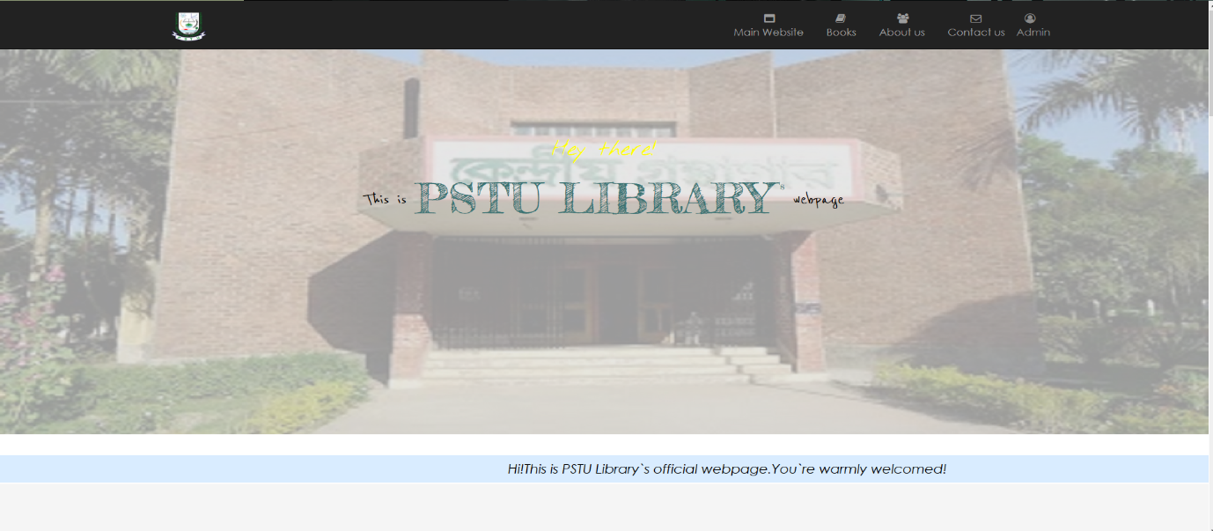

Fig: 1- Front page of PSTU Library webpage

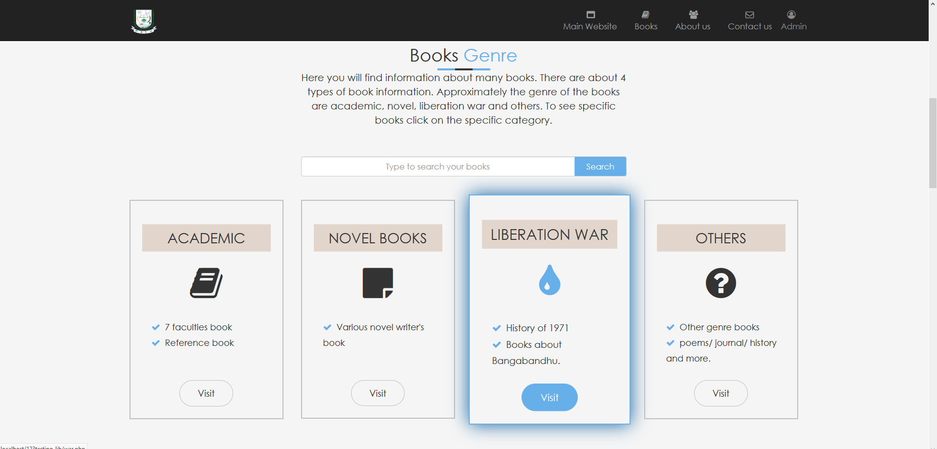

Fig: 2- Search books and books genre

This section you can find 4 types of book. Each type holds the data of different type of book and search box’s word shows a new page to see the searched result.

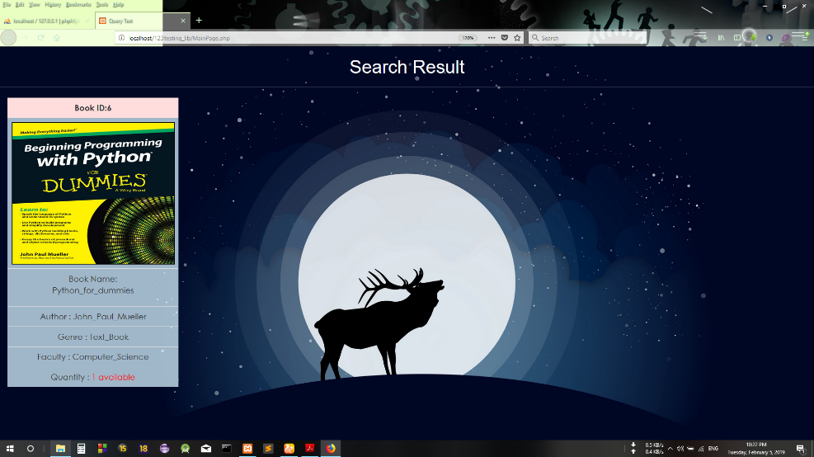Fig: 3 – Searched result

Here, you can see the detailed information of a book and know the available quantity of a book.

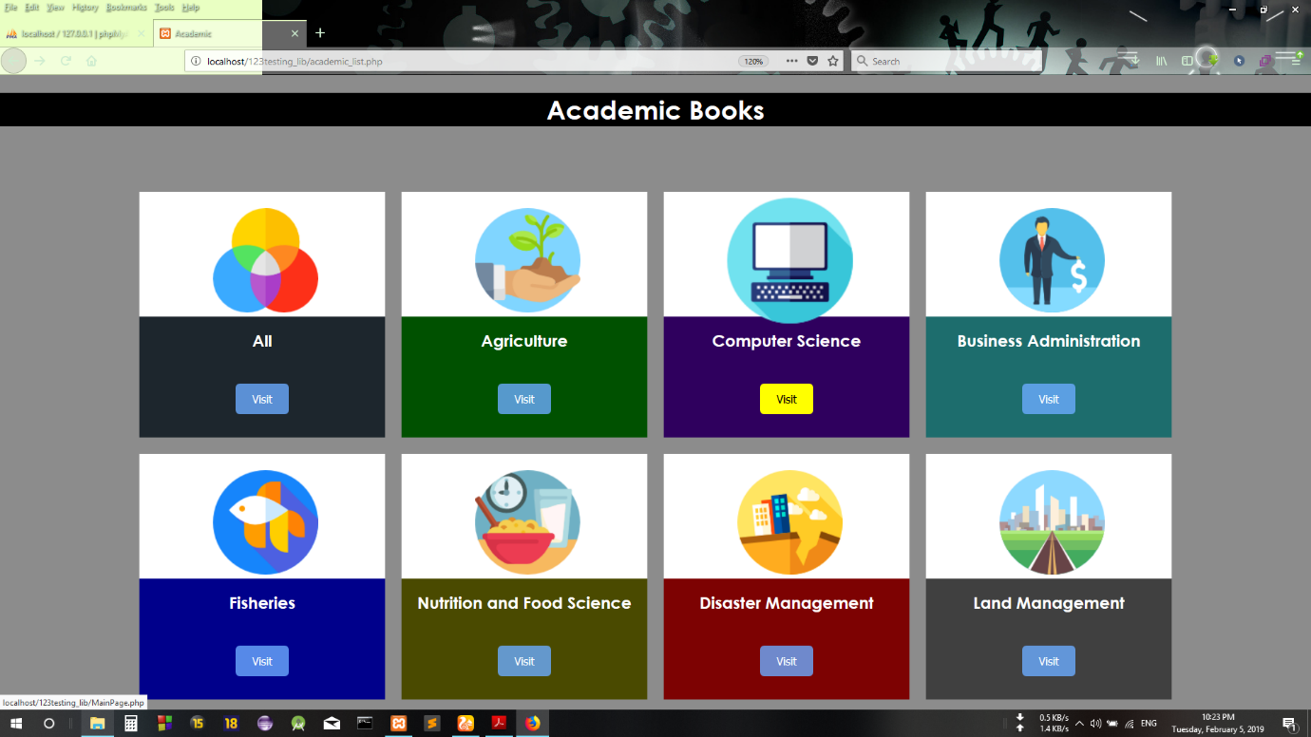

Fig: 4 – Academic genre

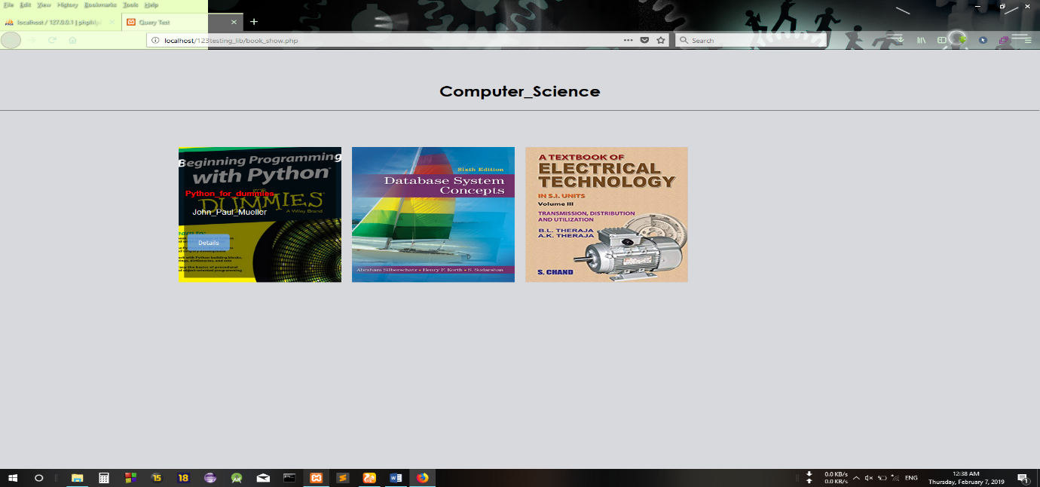After clicking on academic genre you can see this view. Here you can see 7 faculties book as central library contains 7 faculties book. Each section contains each faculties book. For example if you click on Computer Science section then you can see the available book list in a new page.

Fig: 5 – Computer Science section

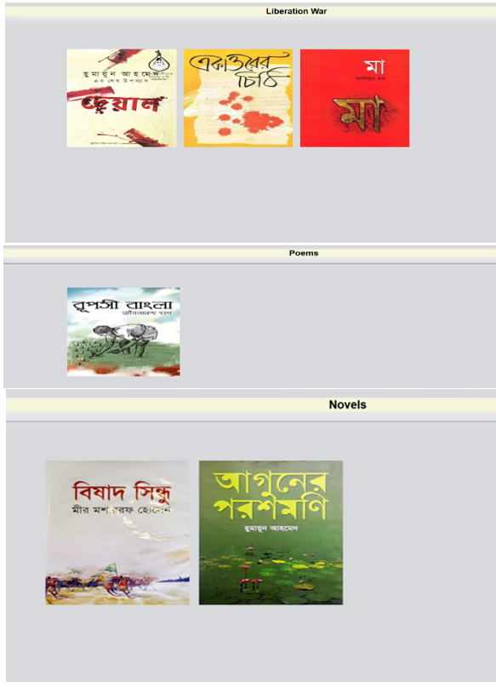 Fig: 6 – Novels,Liberation war, Poems genre books.

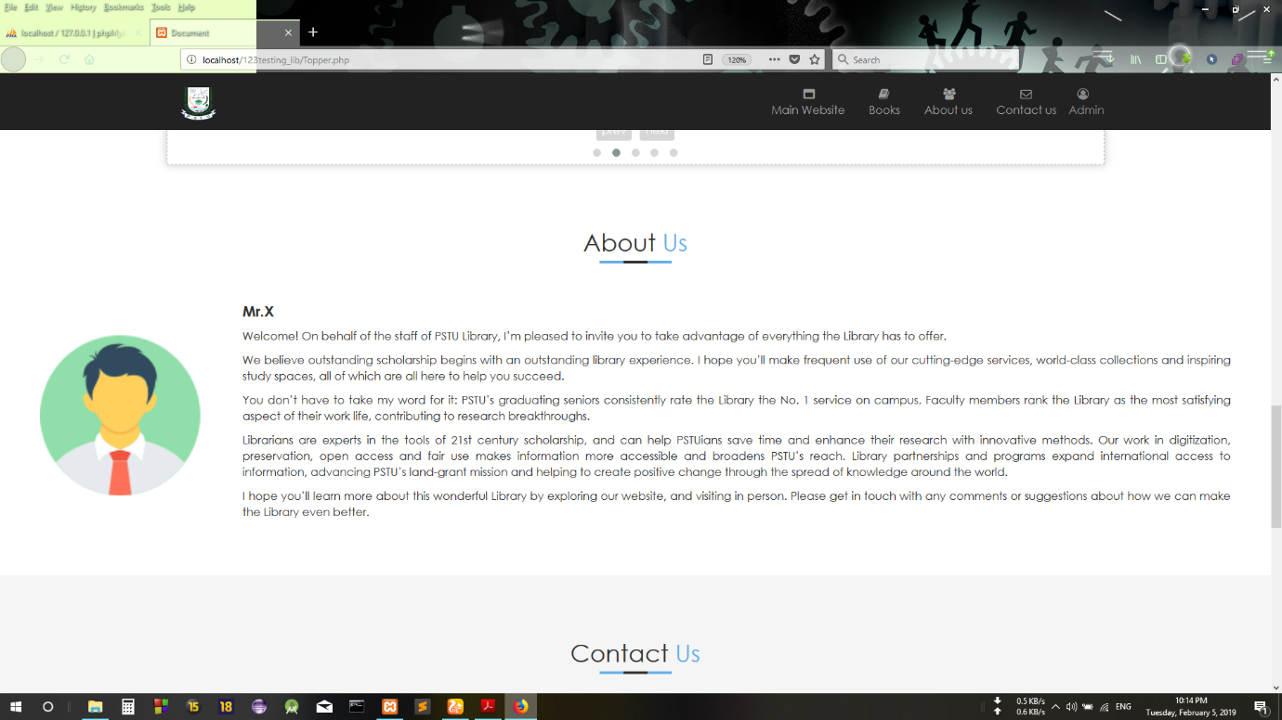 Fig: 7 – About us

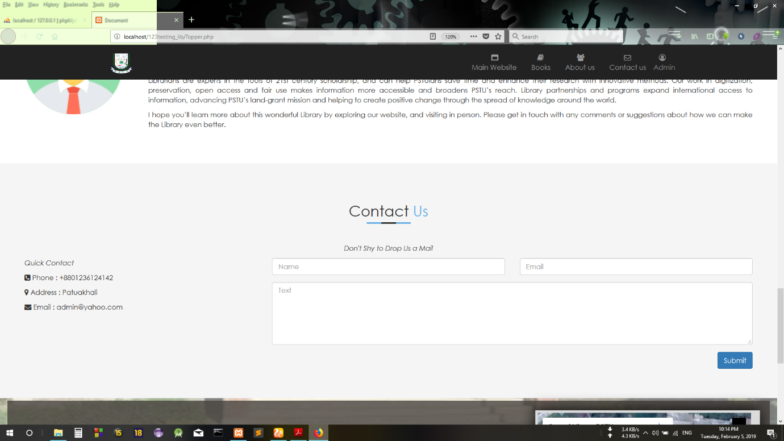This section, you can see the commitment of the librarian.

Fig: 8 – contact us(feedbacks)

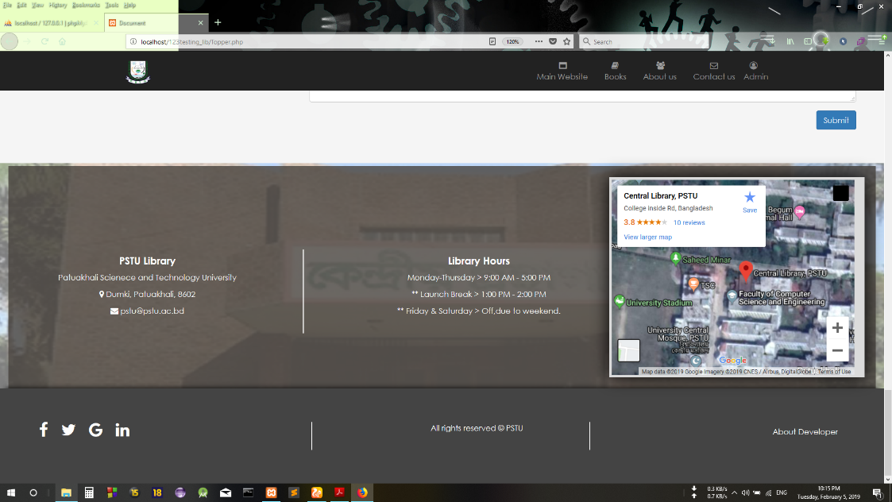 Fig: 9 – footer

In footer section you can see the map of PSTU library, you can know the library hours.

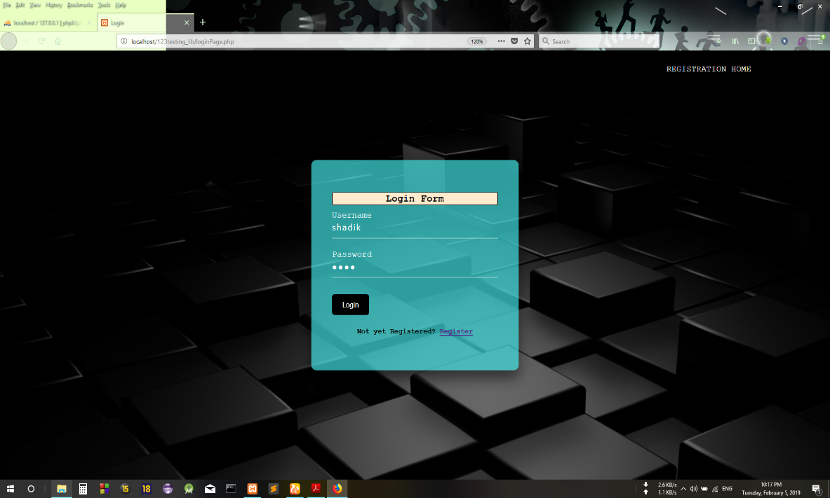On the top of the page you can see there is a menu for admin. If you click on admin, then there appears a login page and if you inserted right username and password then you can go to the next page that means admin page.

Fig: 10 – login page

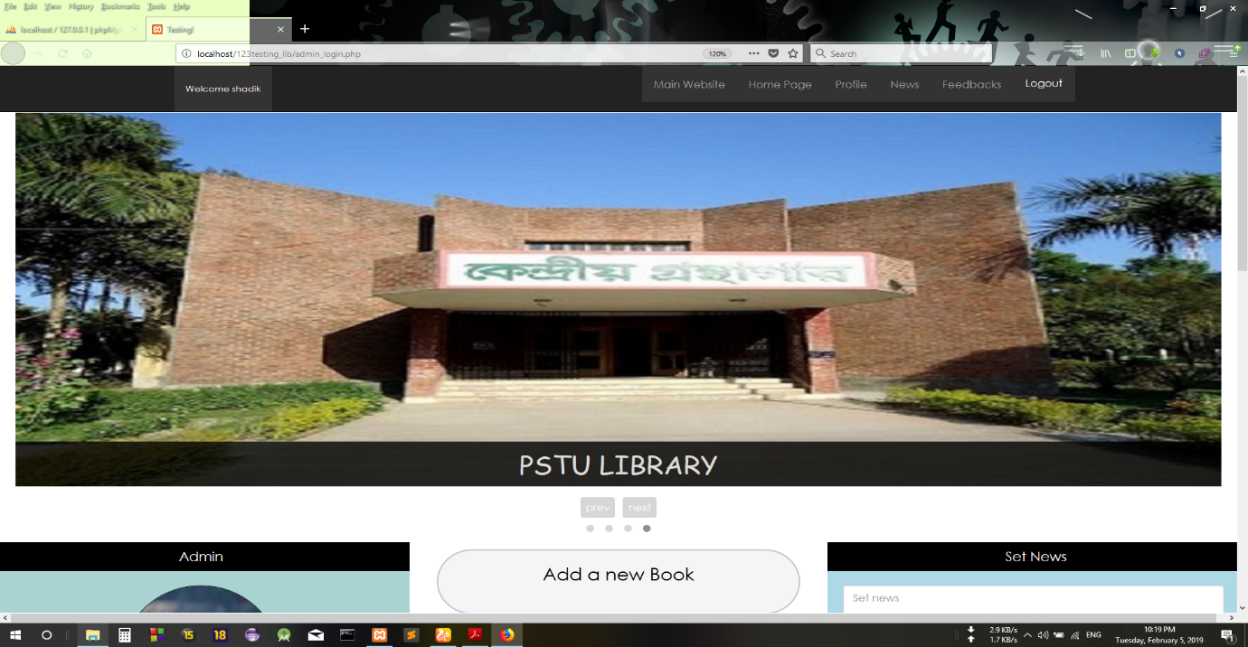As I inserted the right username and password then, the admin page appears.

Fig: 11 – Admin page

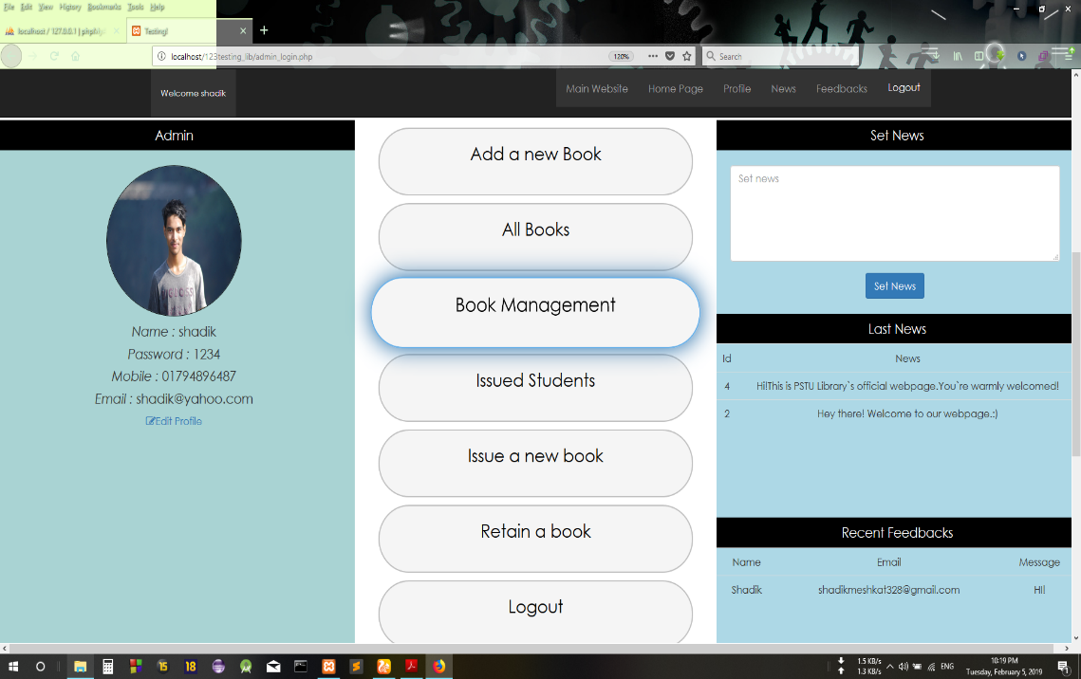 Fig: 12 – Options for admin

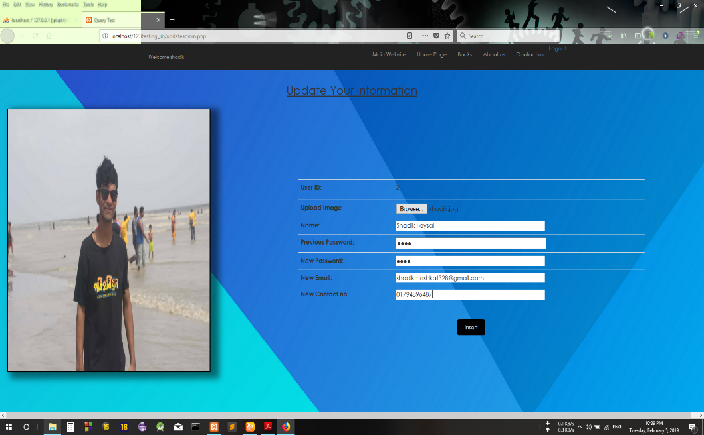Here admin can see his profile with his picture, name, password, email. He can edit his profile by clicking on edit profile.

Fig: 13 – Update admin profile

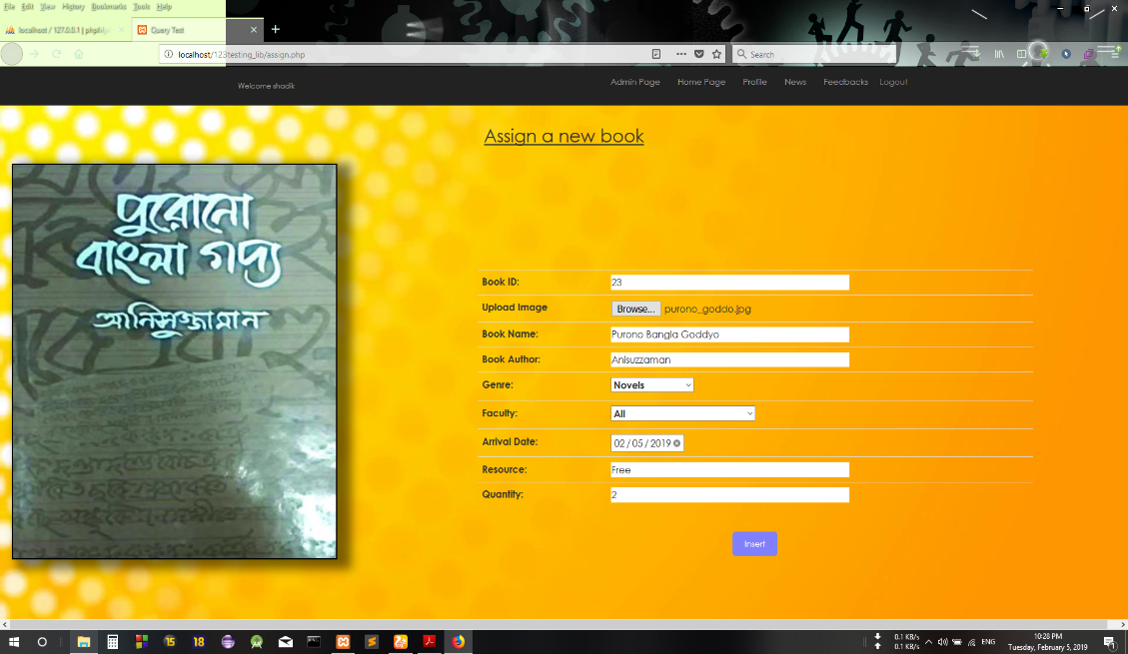There are 5 options for an admin, he can add a new book, book update/delete, manage issued students, issue a new book, retain book. If he click on add a new book then a new page appears.

Fig: 14 – Add a new book

After clicking insert button, new book added to the database with information.

If you click on book management, as you are admin so you can delete/update a book with pagination.

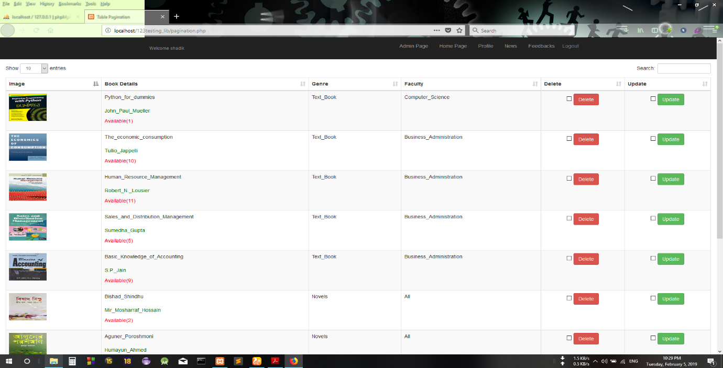

Fig: 15 – Book management

Here you can update and delete any book.

If you click on ‘Issue a new book’ then you can see whole list of available books.

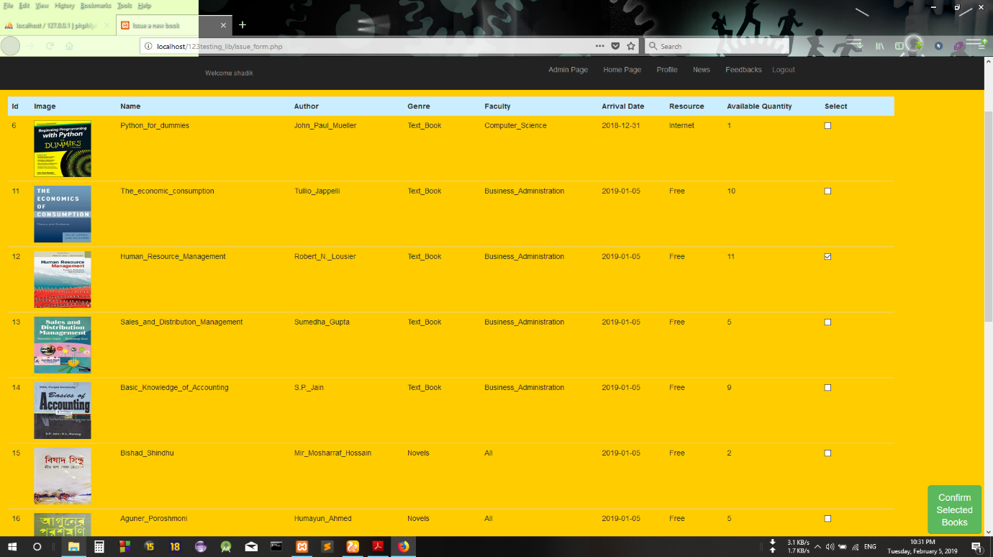

Fig: 16 – Issue a new book(page-1)

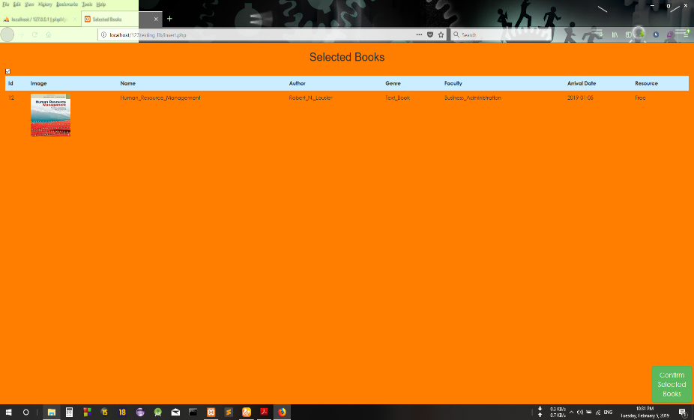Fig: 17 – Issue a new book(page-2)

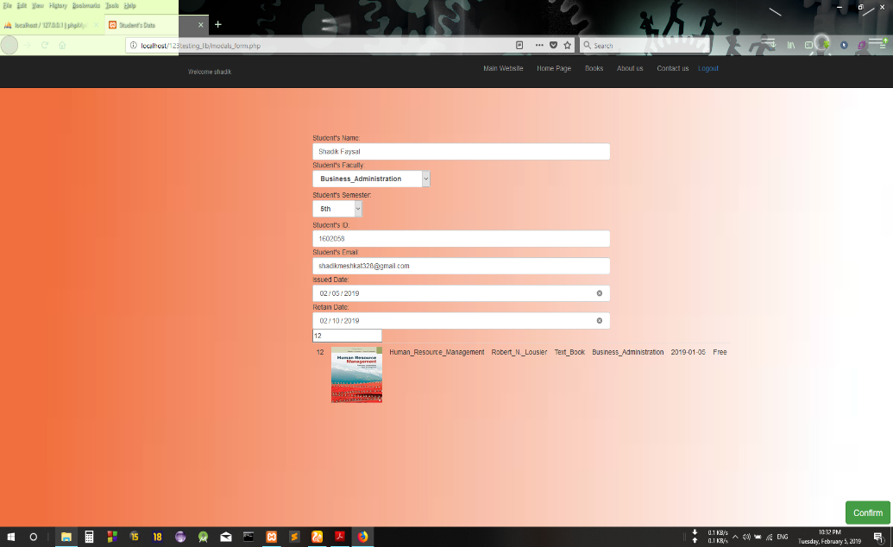There is a select option for each book and you can select at least 1 book and at most 3 books. After selecting a book as example ‘Human Resource Management’ book then the book’s data goes to the next page. And again confirm selected you can see a new page where you have to insert the student’s data.

Fig: 18 – Issue a new book(final page)

After clicking confirm button, the student’s data saved to the database and you can see the student’s data on issued student page and the available quantity of a book decrease by one.

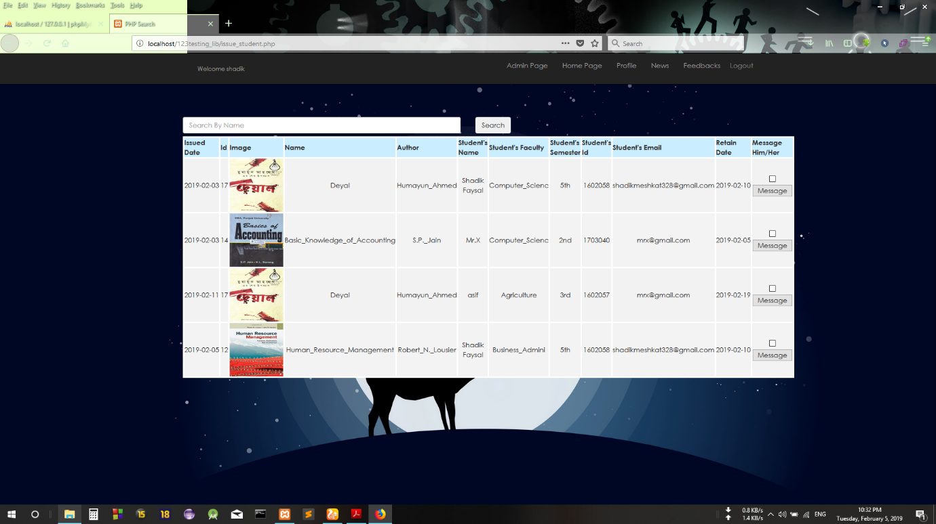If you click on ‘Issued Student’ then a new page appears.

Fig: 19 – Issued students

In this list, you can sent mail to inform the students.

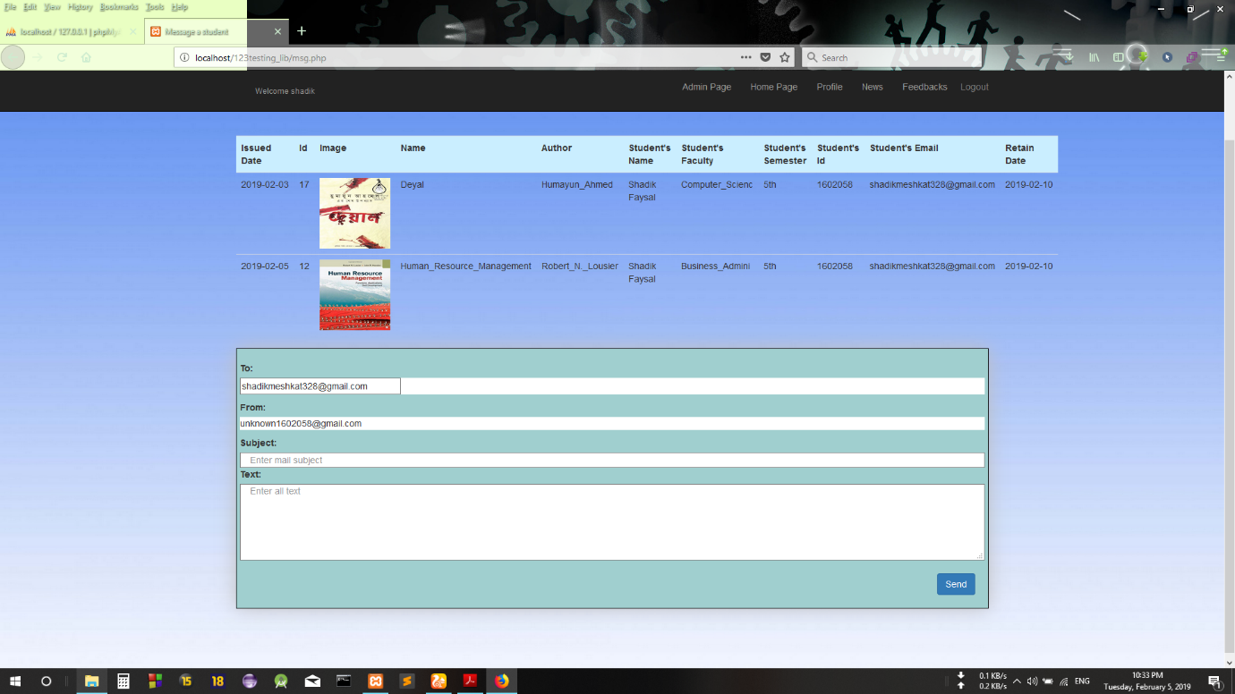 Fig: 20 – Mail

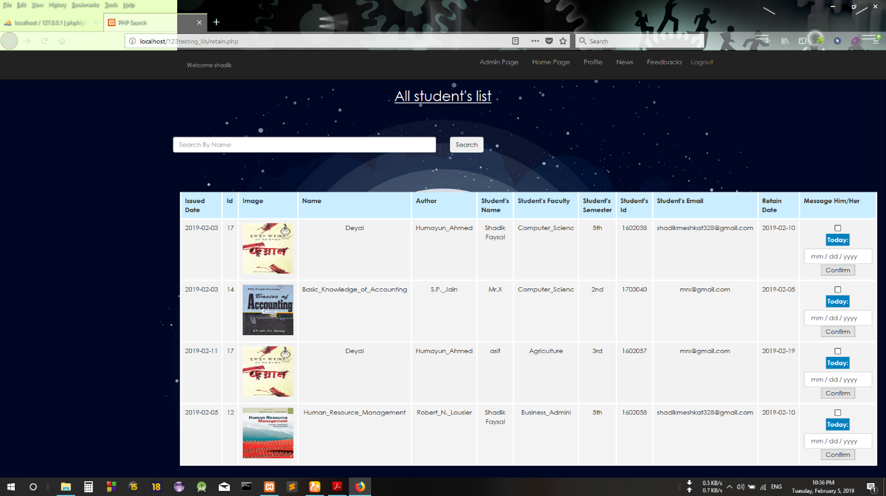

Fig: 21 – Retain of a book

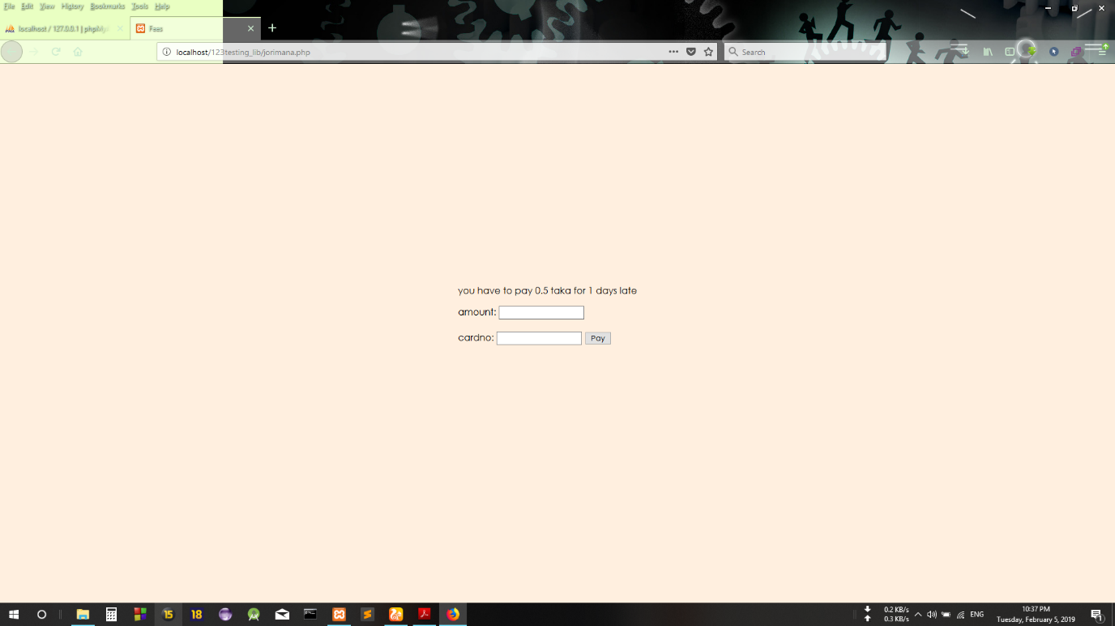For retaining of a book, you have to select today’s date. If the retain date and selected date matched or lower then easily retain the book without any fine. If the selected date over then fine counts 0.5 taka for each day late, and you have to pay the fine.

Fig: 21 – Fine

After retaining of a book, the quantity of the book increased by one and the student’s name from the issued student page will be removed automatically.

In the right side of the figure-12 you can add new news which will be set in the front page and also read the feedbacks.

**Using Languages:**

1. HTML
2. CSS
3. Bootstrap 3.3.7
4. PHP
5. PHPMailer (for sending mail)
6. Owl Carrousel (Slider)
7. JavaScript
8. Jquery

**Limitations:**

1. Feedback should be totally gmail based.
2. There should be a part for student login section, student’s all data and profile.
3. Admin can not be able to upload important files instead of news.

\*\**Special thanks to Moinul Islam Sayed sir, for inspiring me to make this web project.*

*--------------------*o-----*--------------*